Hi Erasmus+Project friends!
It’s a Turkish Coffee

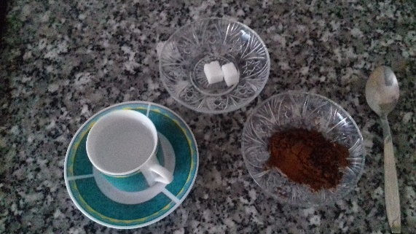

Ingredients:

1 Sugar Spoon Of Turkish Coffee
2 Sugar Cube
1 Cup Water

Preparation :

First, 1 cup of water is put into the coffee pot.
Then 1 sugar spoon of coffee is added to water and 2 cubes of sugar are thrown (if there is no sugar cubes, half a sugar spoon of sugar can be added).
Then these ingredients are mixed and left to boil.
Coffee pot is taken from the stove.
You can pour the coffee into the cup and drink it.

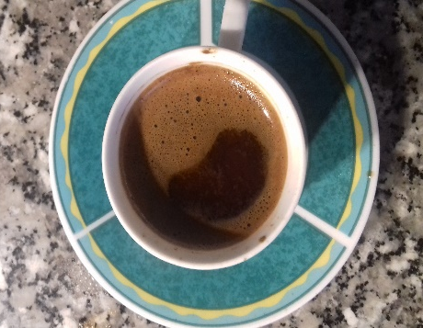

Prepared by Cansu DEMİR,6/E,Turkey.
According to Turkish proverb,a cup of Turkish coffee will be remembered for forty years.

BON APPETIT

