Vegetable Salad
Sałatka Jarzynowa
Antoni Fila 6A

Ingredients:
- 3-4 medium carrots
- 3-4 medium parsley
- 1 celery
- 1-2 medium potatoes
- 5 eggs
- 4 pickled cucumbers
- 1 large apple
- canned peas
- mayonnaise
- 1 spoon of mustard
- pepper, salt
You can also add natural yogurt

A method of preparing:
1. At the beginning, wash raw vegetables.

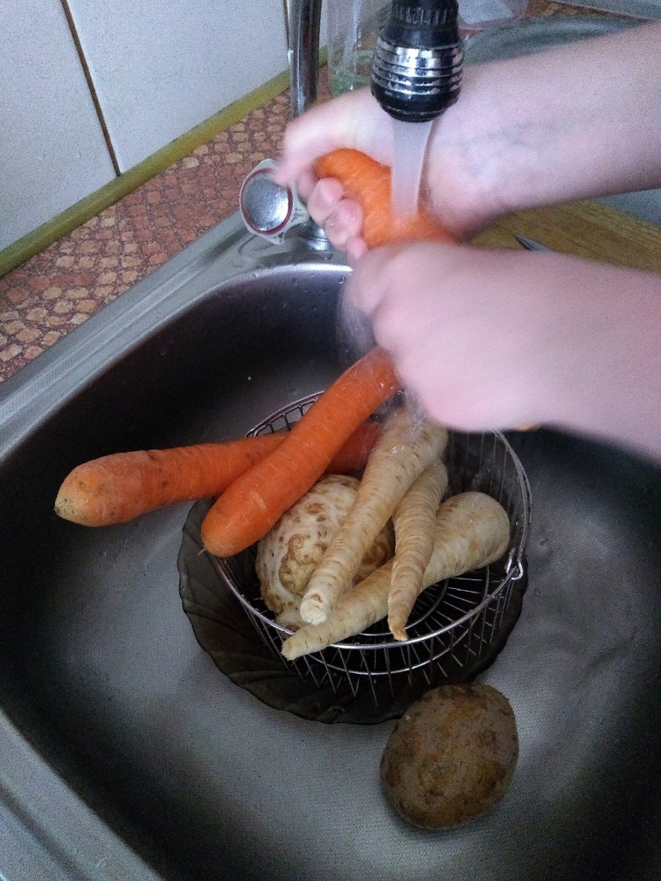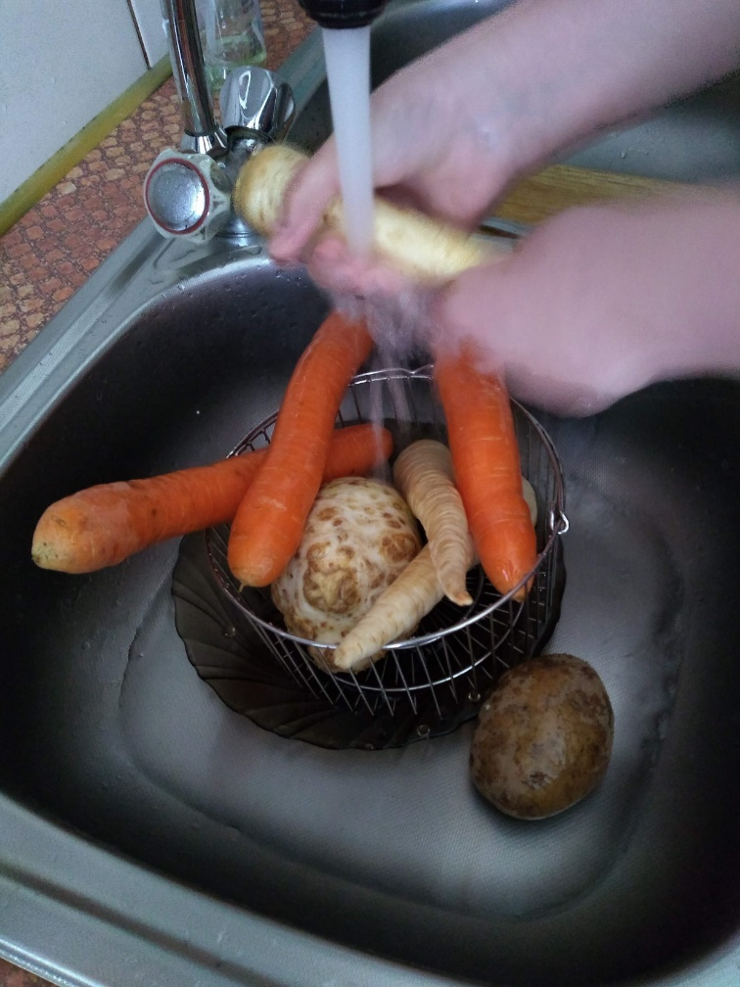

2. Then steam the carrots, parsley, celery and potatoes (about 45 minutes) so that they do not lose their vitamins. Cook eggs separately.
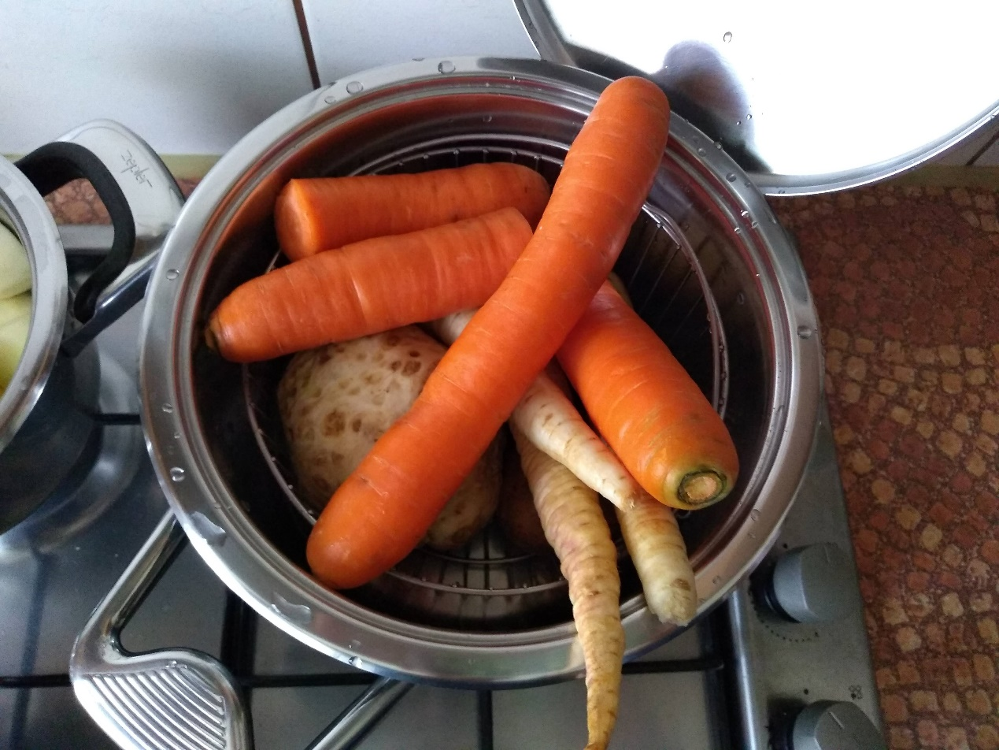

3. After cooling, peel vegetables and eggs, cut all ingredients into small cubes and finally add canned peas.
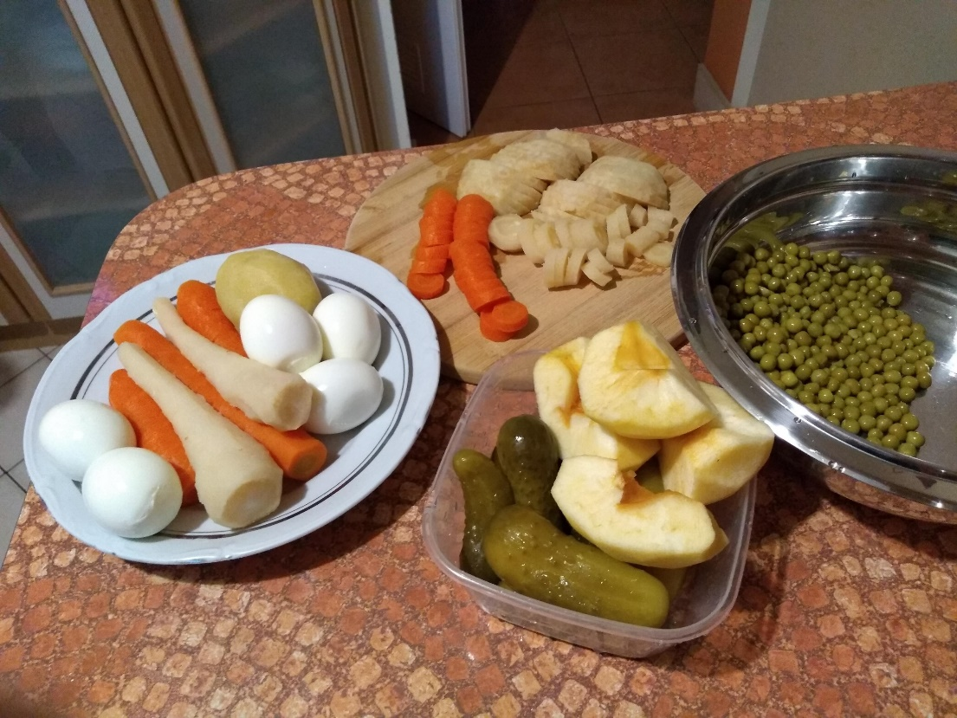
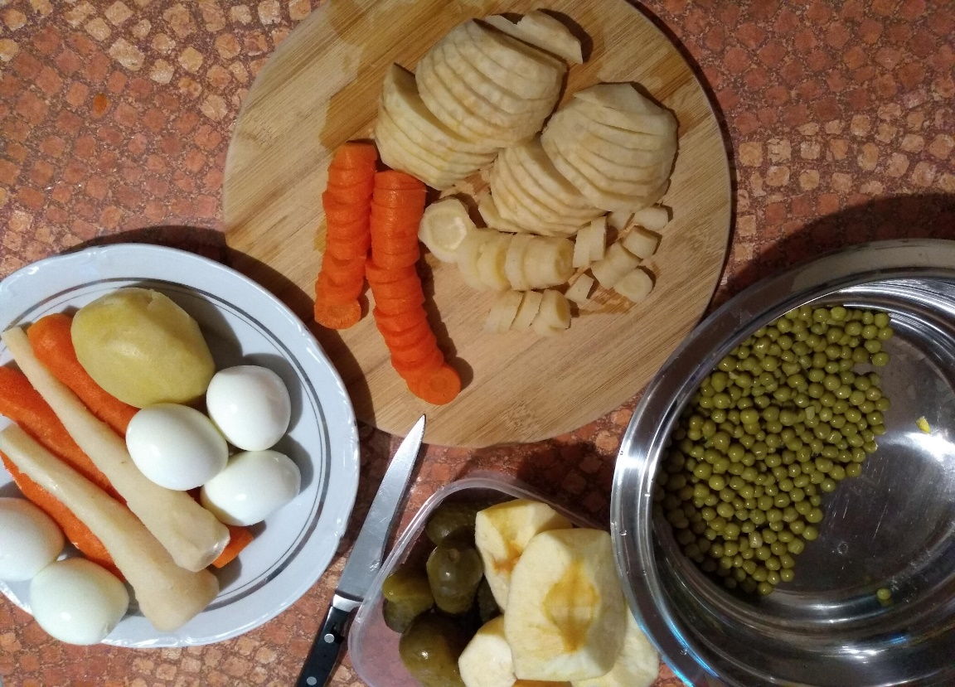

4. Mix chopped ingredients, season with salt and pepper, add mayonnaise, mustard and yogurt.
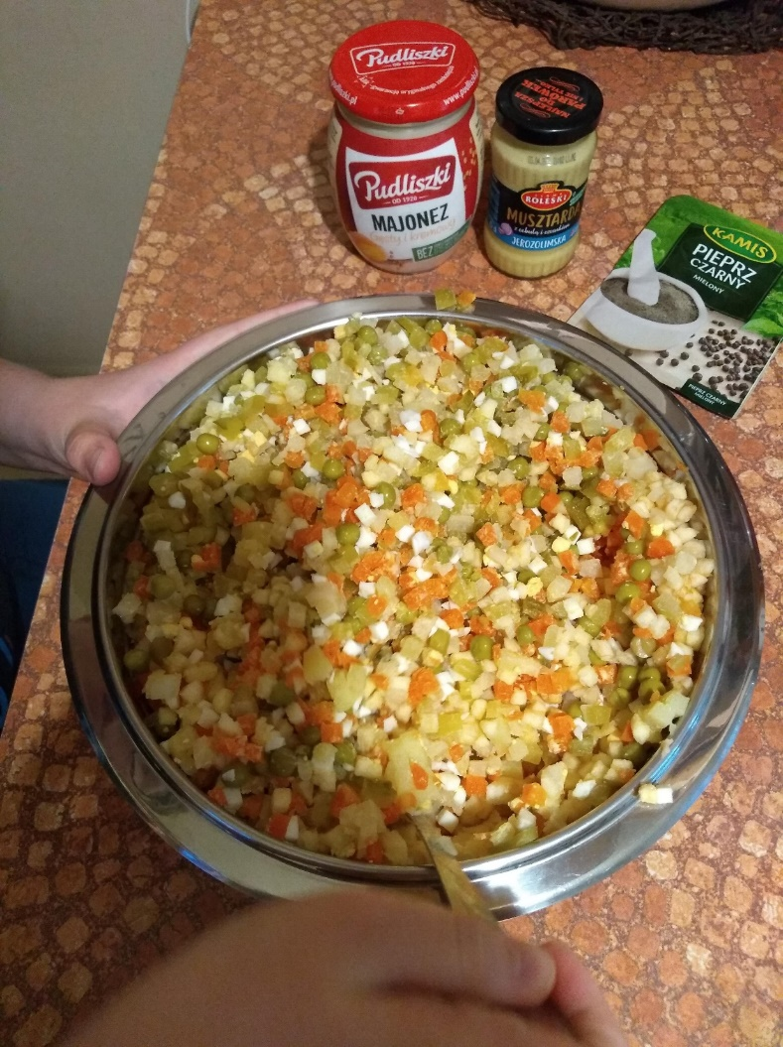
5. When the salad is ready, put it into a bowl and decorate with green dill or parsley leaves.
Bon Appetit!
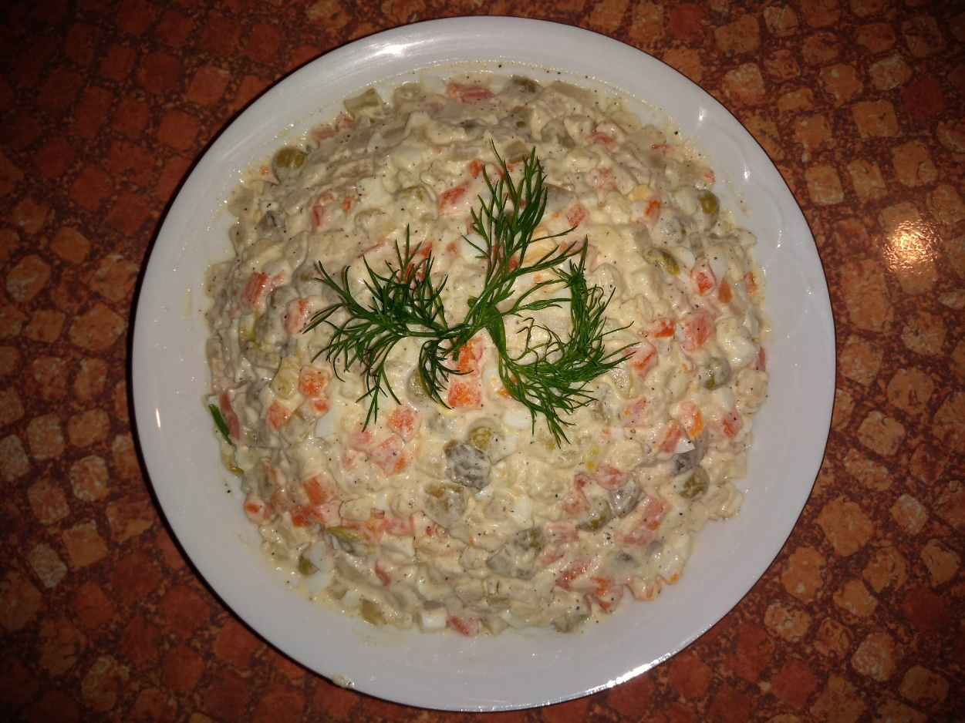

Positive features of the salad:
Vegetable salad consists of vegetables and fruits. It contains a lot of beneficial vitamins and minerals. Eating fruits and vegetables is very healthy and they can be eaten either raw or steamed. It can be consumed by everyone who likes healthy food with a small amount of calories. It is also easy to prepare :).

